Glyn Jones
54 Ridge Street,
Wollaston,
Stourbridge,
West Midlands
DY8 4QF

(Tel.No.01384 371733)
e-mail glyn.jones6@blueyonder.co.uk
13th.September 2021

Midland Area Race Walking Association.
Winter League Series 2021.

The 1st.Midland Area Winter League Series 2021 is now scheduled to take place at Stourport Sports Club, The Kingsway, Stourport-on-Severn, Worcs. DY13 8BQ on Sunday 10th.October 2021.

The pandemic is far from over and so please be aware on personal responsibility for reducing risks. It goes without reminding people that any individual should not risk attending any event if displaying symptoms of Covid -19. It is important to remind ourselves of the importance to remember health and safety at all events.

An entry form is attached and should be completed separately by each individual taking part in the races. The entry form must be completed fully i.e. contact tel.no. in case there is a need to notify anyone following the event regarding any health issues.
There will be toilet facilities in the main building and it is anticipated that there will be changing facilities and all athletes are advised should they wish to arrive ready changed to race together with suitable dry tops/clothing following their particular race.

It is paramount that we follow the SSC protocol and the general guidelines regarding social distancing, hand sanitising and track and trace at all times.

A map of the course is attached, showing all starts and finish. The athletes will race in an anticlockwise direction around the course. Once each athlete finishes then he/should leave the finish area immediately so as to safe distancing. Results will be emailed to everyone later that same day/following morning.

At all times only the area marked for ‘Warm Up’ should be used and not anywhere on the course. When athletes are not warming up or racing then it is down to the individual if he or she wishes to wear face covering and this includes whilst in the main building.

Whilst these are still challenging times and an ever-changing situation your patience and understanding is appreciated and lets all make this work to get us through this difficult time we are still in at this moment in time.

Entry Fees:
Over 17yrs - £5 per race. (Men/Women are allowed to double up in the 5km and 10km but must pay for each race)
Over 11yrs – Under 17yrs - £4 per race.
Under 11yrs - £2per race.

Entry fees may be made by either cheque (payable to Midland Area RWA) or by Bank Transfer (Details: Account Name- Race Walking Association Midland Area,
Sort Code- 54-21-13
Acc.No. 01013130
Ref. Winter League.)

No cash payments please.
Closing date for all entries – Wednesday 6th.October 2021
All entries apart from the 1km will receive a handicap allowance as in previous years.

Race Times.
12.50pm – 5km (Men & Women & U/17’s.
1.30pm – 1km (Boys & Girls U/11yrs)
1.30pm - 2km (Boys & Girls U/13yrs)
1.30pm - 3km (Boys & Girls U/15yrs)
1.55pm – 10km (Men &Women)

Do not encroach onto the cycle circuit before 12noon as the circuit has only been booked from 12noon.

Note: The Winter League comprises of 3 Series and the 2nd.Series is now scheduled for Sunday 21st.November 2021 (Venue TBC) and the 3rd Series on 12th.December 2021 (Coventry)

Yours Glyn Jones Competition Secretary.
Stourport Cycle Track Race Walking Route
The distances quoted are approximate!

855m Loop (anticlockwise):
1km = One lap + 145m
2km = Two laps + 290m
3km = Three laps + 435m
5km = Five laps + 725m
10km = Eleven laps + 595m
3
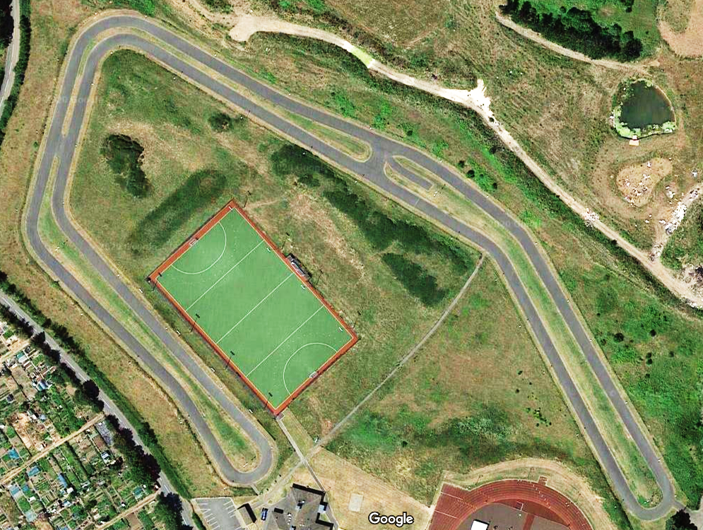
Warm Up Area
Posting Board
Finish
10km Start
100m Mark
Enter
Exit
HQ
5
5km Start
2km Start
3km Start
45
25
1
100m
1km Start
P

Midland Area RWA.
Midland Winter League Series 2021
10th.October 2021, 21st.November 2021 , 12th.December 2021.

Entry Form.

First Name……………… Surname………………………………
Address………………………………………………………………
…………………………………………………………………………
…………………………………………………………………………
Post Code…………………………………
Telephone Number………………………………………………….
e-mail address………………………………………………………….

Date of Birth………………………… Gender(M/F)………………
EA Affiliated Club…………………………………………
Competition Licence Number………………… County………………

I wish to enter (please tick) 10km [ ] 5km [ ]
Under 15 Girls 3km [ ] Under 15 Boys 3km [ ]
Under 13 Girls 2km [ ] Under 13 Boys 2km [ ] Under 11’s Development Boys and Girls [ ] 1km.

Declaration: I agree to abide by UKA rules and accept that neither the race organisers, partner organisations nor sponsors will be held responsible for any injury or illness nor damage to or loss of property resulting from this event. (Parent to sign if athlete under 15)

Signed……………………………. Date…………………………

